**DBMS PRACTICAL-II**

**PRACTICAL EXECUTION:**

Creating Tables:

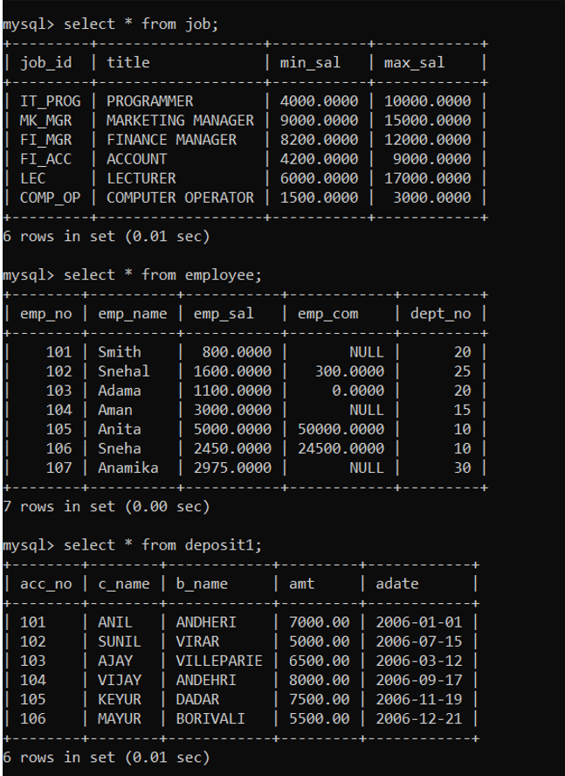

1) To create table Job:

2) To create table Employees:

3) To create table Deposit2: Inserting Data into Tables:

4) Insert Data in Job:

5) Insert Data in Employees:

6) Insert Data in Deposit2: Queries to be performed:

7) Retrieve all data from employees, job and deposit2. Output:

EMPLOYEES:

JOB:

DEPOSIT2:

(8) Give details of account no. and deposited rupees of customers having account opened between dates 01-01-06 and 25-07-06. Output:

(9) Display all jobs with minimum salary is greater than 4000. Output:

(10) Display name and salary of employee whose department no is 20. Give alias name to name of employee. Output:

(11) Display employee no, name and department details of those employee whose department lies in (10, 20). Output: To study various options of LIKE predicate:

(12) Display all employee whose name start with ‘A’ and third character is ‘A’. Output:

(13) Display name, number and salary of those employees whose name is 5 characters long and first three characters are ‘ANI’. Output:

(14) Display the non-null values of employees and also employee name second character should be ‘N’ and string should be 5 character long. Output:

(15) Display the null values of employee and also employee name’s third character should be ‘A’. Output:

(16) What will be output if you are giving LIKE predicate as ‘%\_%’ ESCAPE ‘\’ Output:

VIVA QUESTIONS:

1) Can you sort a column using a column alias?

2) Is a NULL value same as zero or a blank space? If not then what is the difference?

3) Say True or False. Give explanation if false:

4)If a column value taking part in an arithmetic expression is NULL, then the result obtained would be NULL?

5) If a table contains duplicate rows, does a query result display the duplicate values by default? How can you eliminate duplicate rows from a query result?

6) Say True or False. Give explanation if false: The DISTINCT keyword allows a function consider only non-duplicate values